Semester 3 project- English
Assignment for English:
For your semester 3 project, you will be required to give an oral presentation of your project in front of a jury composed of an English teacher and a Computer Science teacher. The whole project team presents together and each member will speak for about 5 minutes, so that each presentation will take between 15 and 20 minutes + 10 minutes for questions.
This presentation will take place on week 3 (to be confirmed).
You project supervisor may be on the jury but you may not find out in advance. You
The ppt should follow this format:
• Slide 1: project presentation complete (name of the website, subtitle SAE3 project
BUT computing- all your names, module, IUT logo, company logo if you have one)
• Slide 2: problem
• Slide 3: solution= your homepage (screenshot)
• Slide 4: specifications
• Following slides: tools used (languages, framework, design pattern)- always clarify who
did what
• Technical demonstration using diagrams
• Selected lines of code with comments
• Illustrated functionalities
• Gantt chart with comments
• Summary of main points and critical analysis

Don’t forget to introduce the whole team and announce who will present which part of the talk. No notes allowed so make sure to have user friendly slides.
Penalties will apply whenever the user or customer is repeatedly referred to as “he” instead of “they”.
Please label your visuals and zoom in on the parts you want to comment on.
Formalise your talk by using the language you learnt last year and again this year for introductions, signposting etc. Take care to use proper transitions (I’ll hand over to Tom who is going to talk about…/ let’s move on to etc).
Make sure you know how to pronounce all the tools you present.

Language of websites
Translate the following terms:
- Authentification :
- Frais de livraison :
- S’inscrire :
- se connecter à son compte :
- Produits/articles disponibles :
- Passer une commande :
- Annuler une commande :
- Suivre une commande :
- Diaporama/ galerie de photos:
- Ergonomique :
- Une experience utilisateur sans accroc :
- La mise en page :
- Menu déroulant :
- L’en-tête :
- Faire defiler :
- Répond aux besoins du client :
- Cette icône vous permet de suivre vos achats :
- La caisse :
- Pied de page :
- Menu extensible :
- Page d’accueil :
- Remplir un formulaire :
- Les articles s’affichent :
Problem and solution format
For each problem, come up with a question about the problem and a solution.
- Ex: “Are you always late paying your bills? Not anymore, with our new bill-reminder app!”
- Or “Looking for a way to pay your bills on time? Look no further, with our brand new bill-reminder app!”
- Or “Late paying your bills again? Our brand new bill-reminder app will solve your problem in no time!”

- Your shoe size is 14 (EU 47) and you can never find shoes your size in shoe shops.
- You keep forgetting to pay your friends back when you borrow money and now they call you stingy
- You hate Christmas shopping
Presenting your project’s specification requirements
- Our brief was to design/ to build
- Our assignment involved designing…
- As part of a team of 5/ in a team of 4
- Key technologies involved include
- Our system needed to
- The application had to support certain functionalities such as
- To achieve this, we used
Refrain from using “we had to design ” too much → “our brief was to design”
Practise using this language by describing your semester 1 or semester 2 project

Commenting on a Gantt chart

Comment on the following Gantt chart by filling in the gaps with expressions taken from the vocabulary list below:

was completed  met  be delayed  scheduled | had been completed  spanned over  a two-week  run | overlapped  extend  took  expected

1. The project was ..................to start in January and ...............................at the end of May.
2. We ......................the project to ............from January to May.
3. Task 1 ..............most of January.
4. Task 2 ..................................January and February.
5. Tasks 4 and 6 ....................
6. Task 4 couldn't start until task 2 ...........................
7. Task 3 was ............................phase.
8. We had to .............................. task 2 by a week in March before starting task 4.
9. Task 5 might ........................... if task 4 goes over schedule.
10. We ........................our deadline.
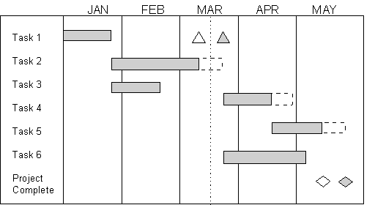

Presenting visuals
The talk must be technical and should include a technical demonstration.
- As you can see here
- I’d like to draw your attention to
- In the top bottow corner/ right top corner/ on the left part
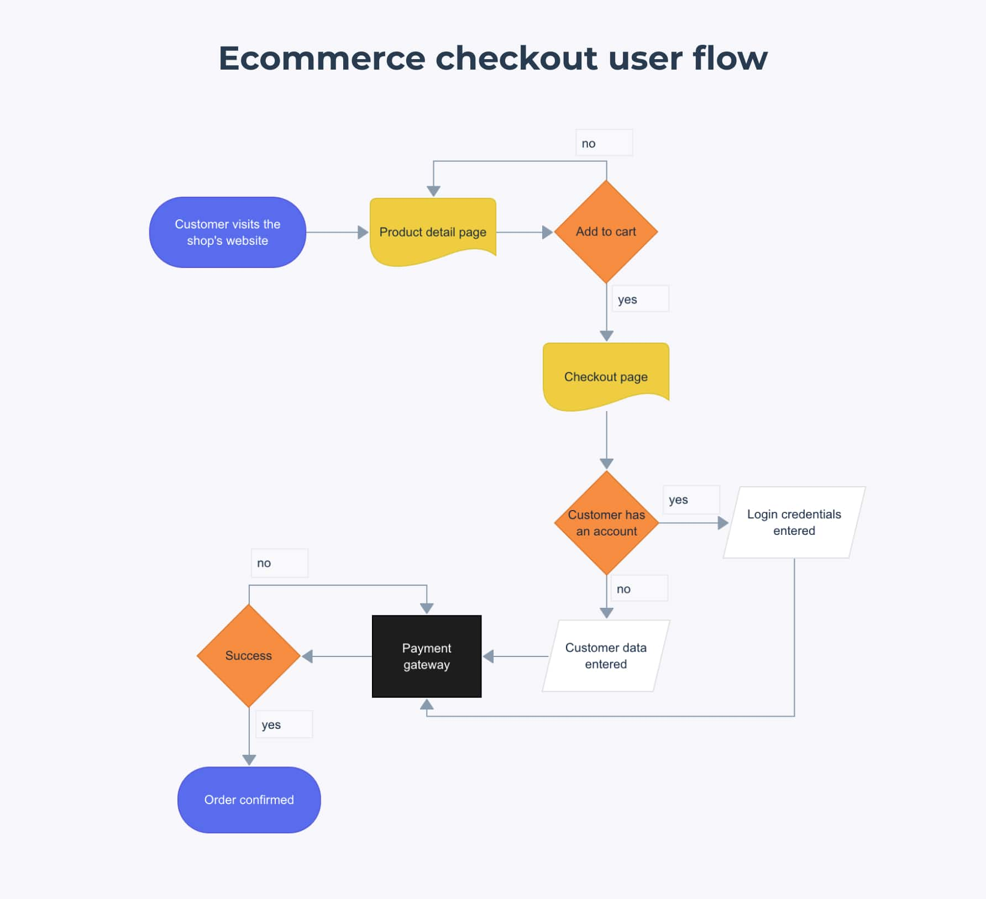
The flowchart represents the e-commerce checkout user flow, detailing the process customers follow from visiting a website to completing an order. Here's the breakdown:
• First, the customer lands on the product detail page.
• If the customer decides not to add a product to the cart, the flow ends here.
• If they add a product to the cart, the flow moves forward.
• Once a product is added to the cart, the customer is taken to the checkout page.
• The system checks if the customer has an account.
• If yes, the customer enters their login credentials.
• If no, the customer must enter their personal data (name, shipping info, etc.).
• After entering the required information (whether via login or manually), the process
proceeds to the payment gateway.
• The payment is processed, and if successful, the flow moves to the next step.
• If the payment is successful, the order is confirmed, and the process is complete.
• For the final step, the customer receives confirmation of the order.

This flow ensures a smooth path from selecting a product to completing a purchase. If there are any issues with the payment, the customer can be redirected back to the checkout to try again.
Now, using this example, practise presenting another flowchart.
For flowcharts or functional diagrams, you will need to use some passive structures
- This flowchart illustrates
- Let me talk you through the process
- First…. Once the user clicks on…
- An item is added to the cart/ an item is then added to the cart
- Useful verbs: validate/ enter data/ complete/ confirm
- Once the item is added, then …
- After entering
- If successful
*Remember: the user= they (not he)
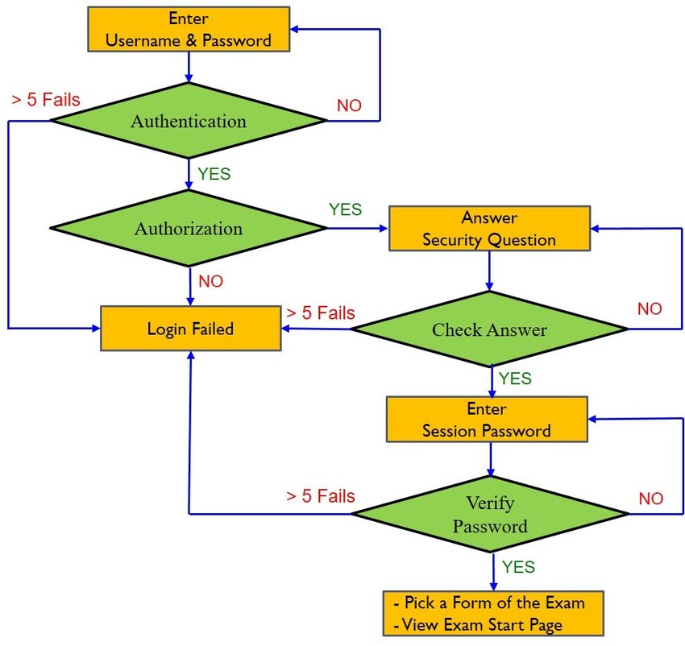
User authentication flowchart
Critical analysis
  - Overall, we feel that/ I felt that
  - On the whole (globalement)
  - I expected/ did not expect
  - As far as.. is concerned/ In terms of methodology/ regarding/ concerning the preparation phase
  - We struggled with/ The trouble was/ … proved problematic
  - One of the key challenges we faced
  - unexpectedly time-consuming
  - this phase took longer than we had anticipated
  - coding-related issues
  - Also/ in addition
  - On the other hand/ by contrast/ contrary to my initial expectations
  - In the end/ ultimately/ we ended up spending more time
  - We managed to overcome/ troubleshoot/ solve
  - We succeeded in implementing (mettre en place)
  - What I found the most challenging/ the most challenging aspect
  - With hindsight/ on hindsight (avec du recul), we should have

Translate the following:

1. Nous aurions dû nous concerter dès le début.

2. Si nous avions davantage réfléchi à la structure, nous aurions perdu moins de temps.

3. Nous aurions dû anticiper le temps de la rédaction des livrables

